JIRA LAB EXPERIMENTS
NAME: VIDULA R COURSE CODE: CSA1013
REG NO : 192511270 COURSE NAME: SOFTWARE ENGINEERING

EXP: 01 - CREATE A KANBAN BOARD TO VISUALIZE THE TASKS
AIM
To create a Kanban Board with To Do, In-Progress, and Done columns, add at least five sample tasks, and simulate the movement of tasks through different stages of completion.
WORKFLOW
- Project Creation
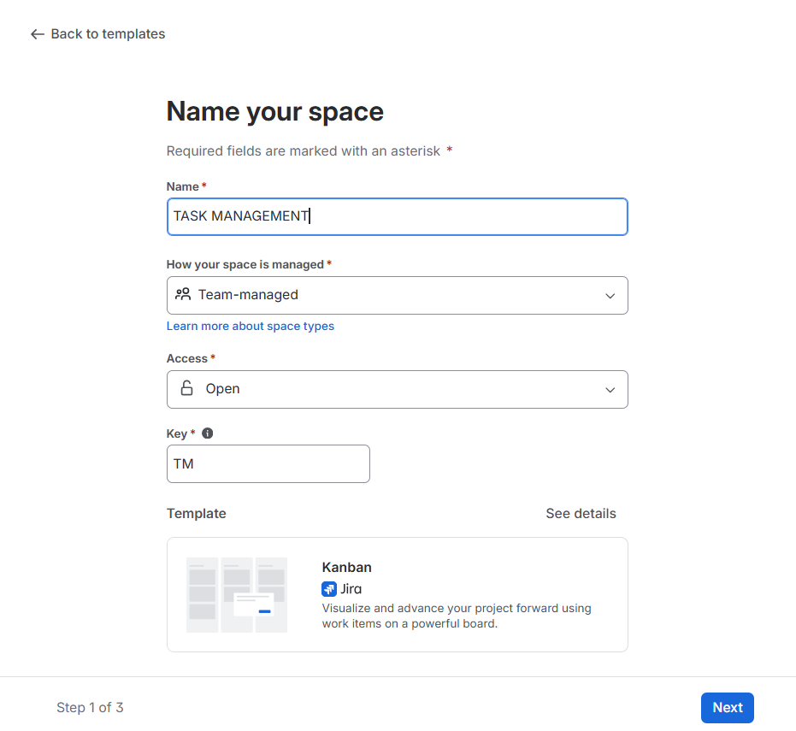

- Empty Kanban Board
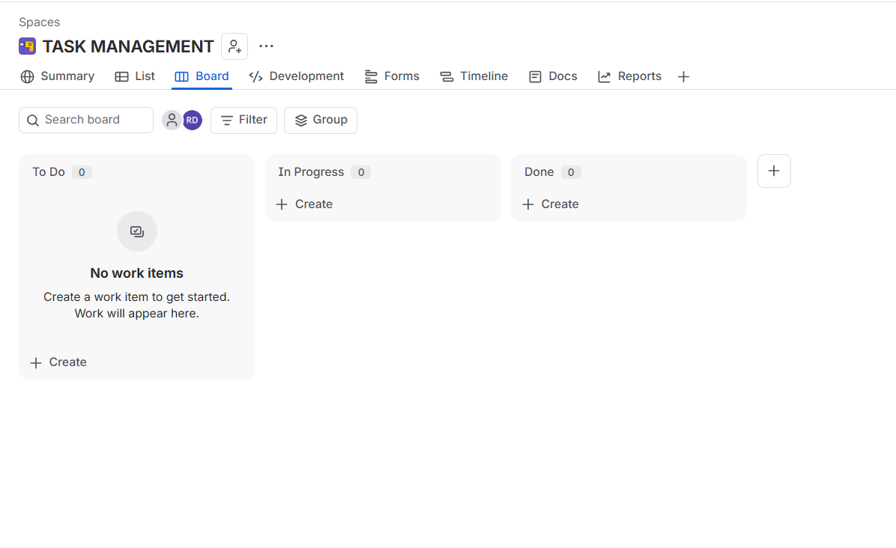
- Tasks Added
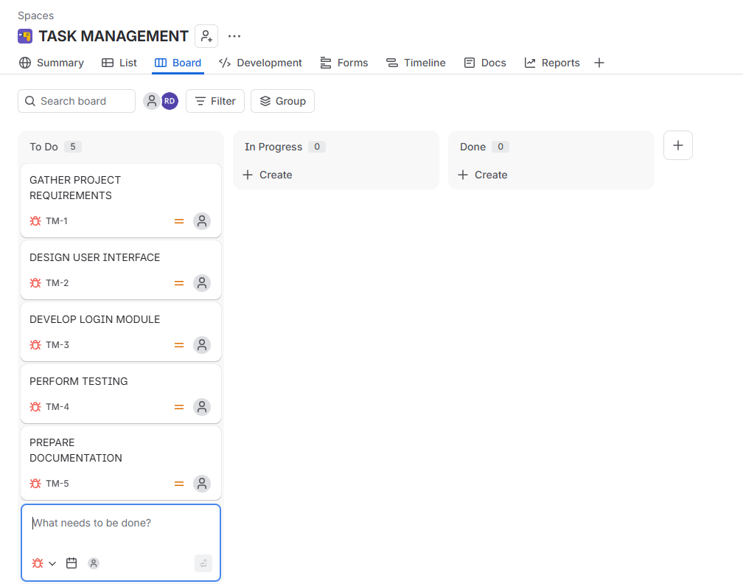

- Task Movement
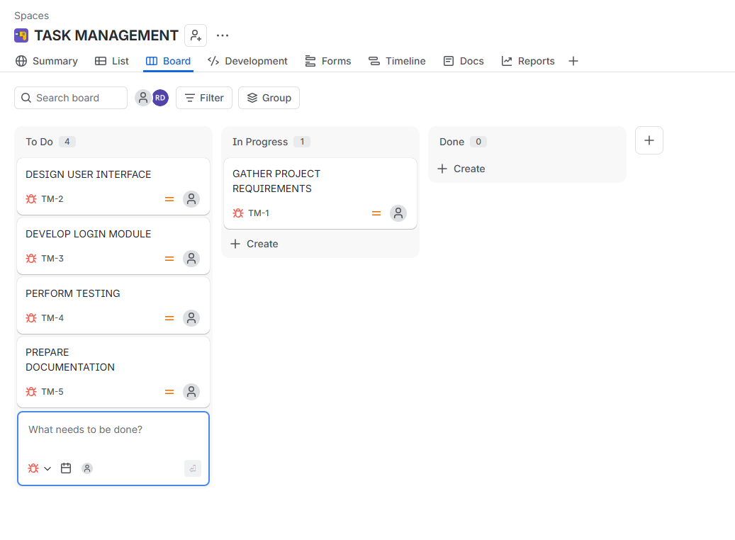

- Final Workflow

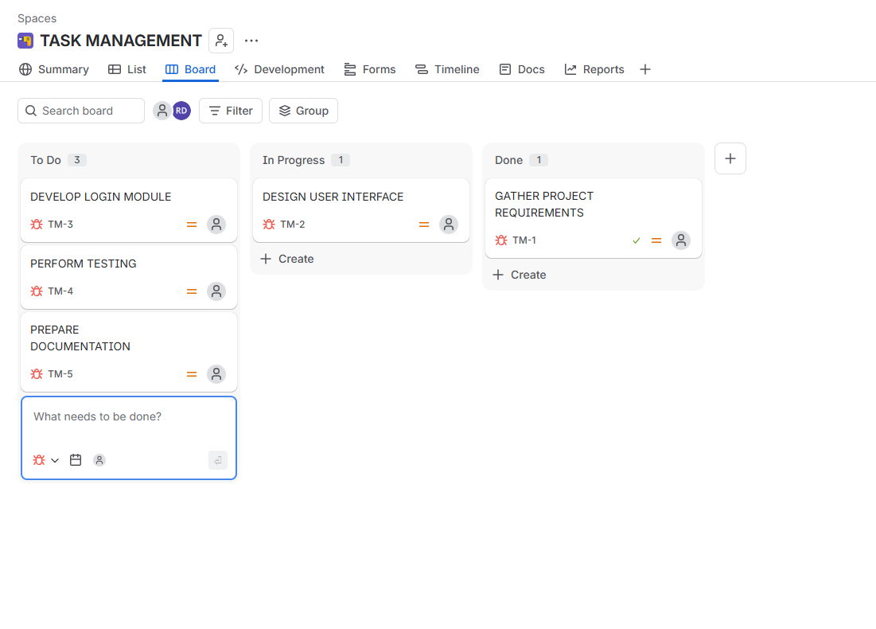
RESULT
The Kanban Board was successfully created with To Do, In-Progress, and Done columns. Five sample tasks were added, and tasks were moved across the columns to simulate the project workflow, enabling effective visualization and tracking of task progress.

EXP:02-CREATE AND MANAGE A SCRUM PROJECT IN JIRA
AIM
To create a Scrum project in Jira, add and prioritize backlog items, create a one-week sprint, move backlog items into the sprint, start the sprint, and track the workflow using the Sprint Board.
WORKFLOW
- Scrum Project Created

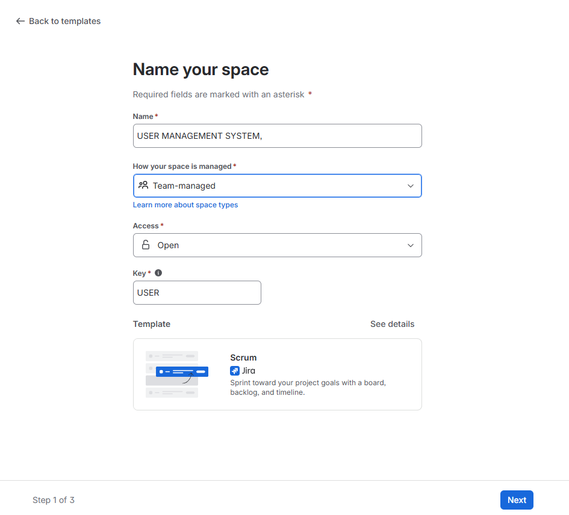

- Backlog Items Added

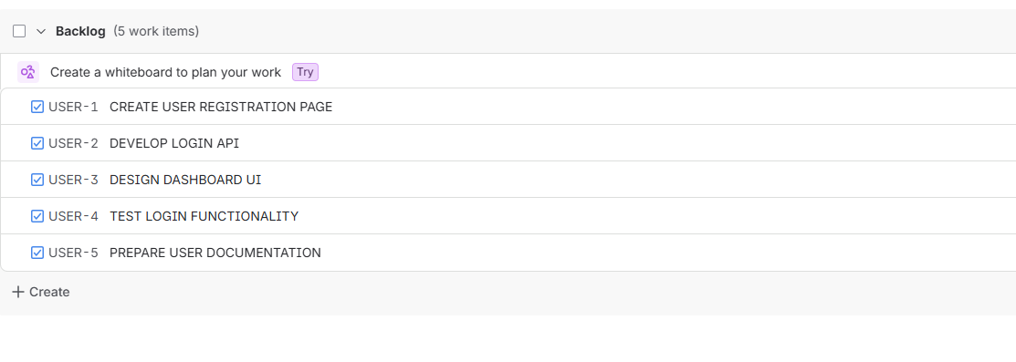

- Backlog Prioritized

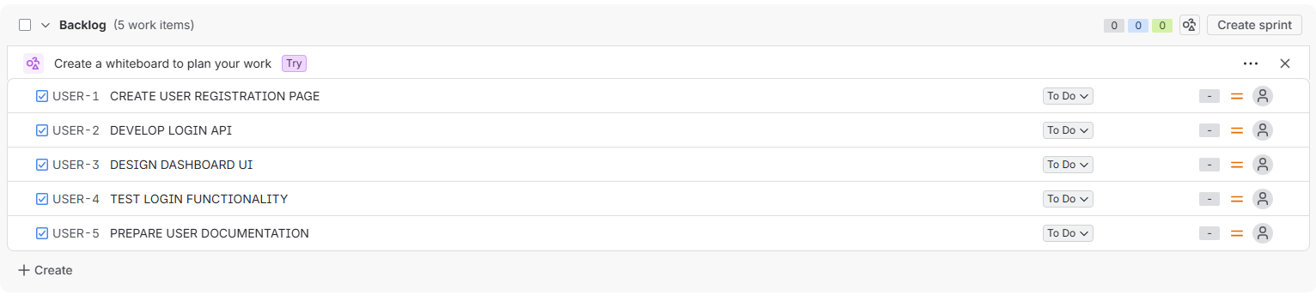

- Sprint Created
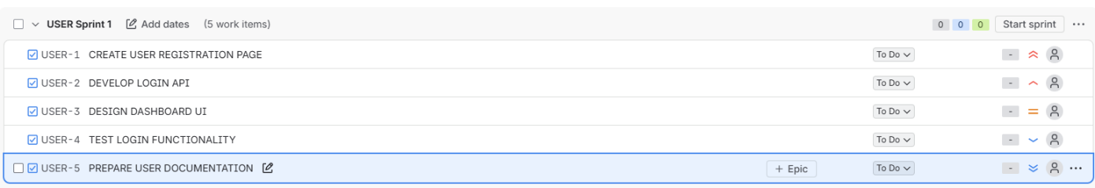
- Sprint Started
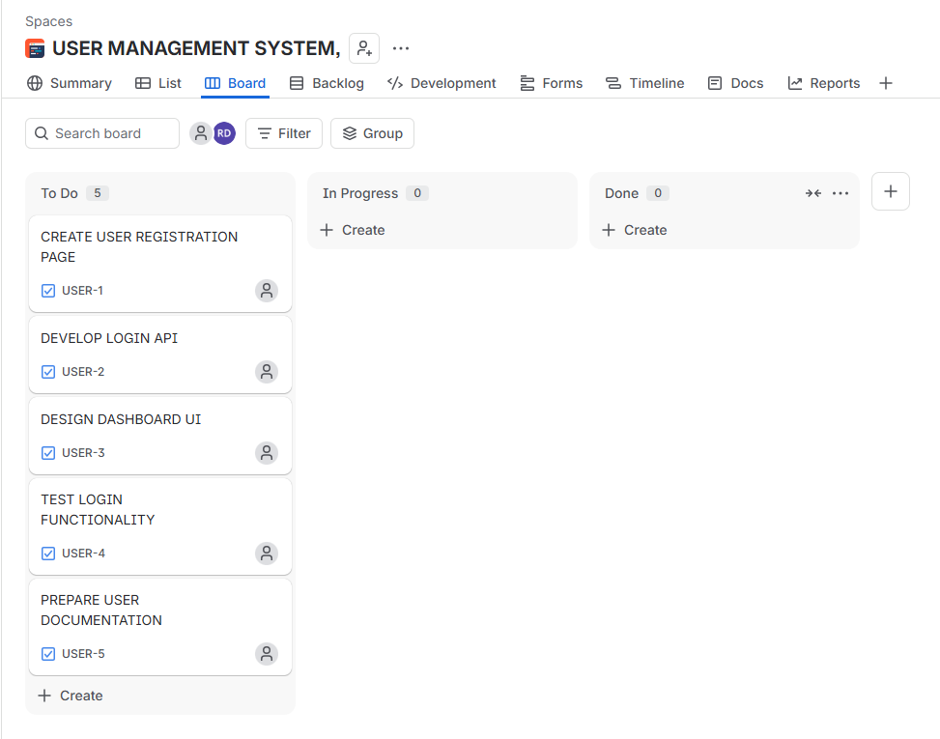

- Sprint Board Updated
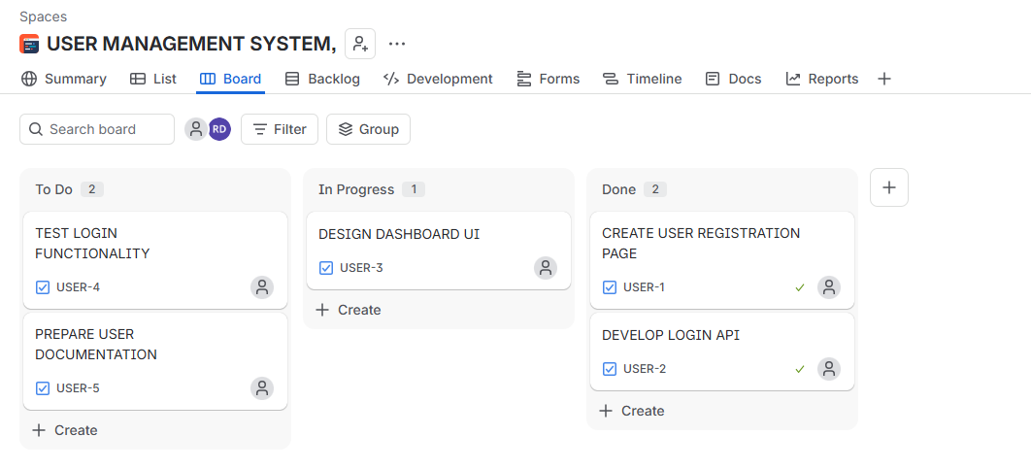

RESULT
A Scrum project was successfully created in Jira. Five backlog items were prioritized, assigned to a one-week sprint, and managed through the Sprint Board. The workflow was visualized by moving tasks across To Do, In Progress, and Done, demonstrating effective sprint planning and task tracking.

EXP: 03 – Integrating Jira with Confluence for Project Tracking

AIM
To integrate Jira tasks with Confluence by creating a project overview page, embedding Jira issues, displaying their status, and tracking project progress using a progress bar.

WORKFLOW
- Confluence Page Created

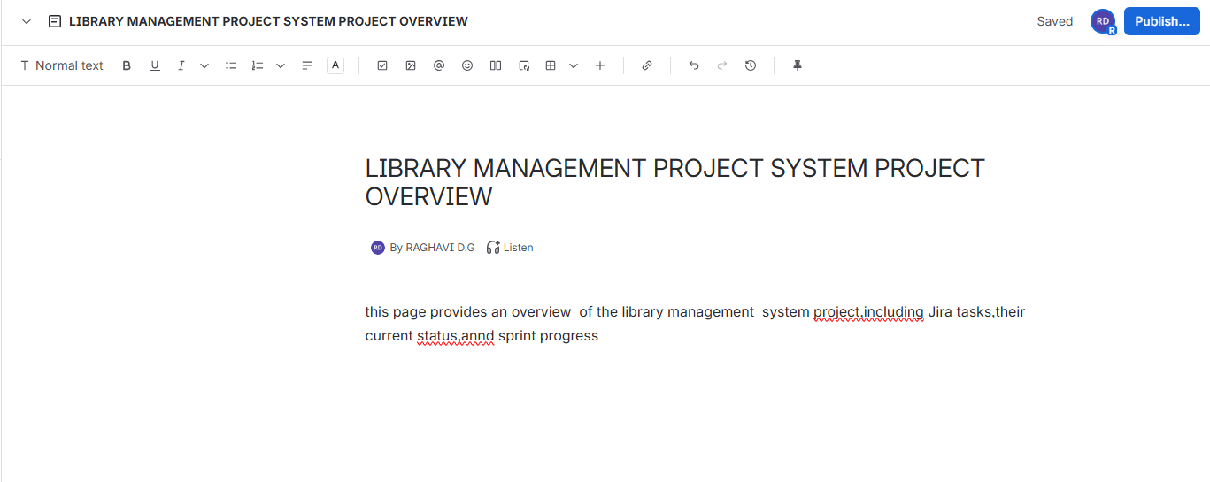

- Jira Issues Created

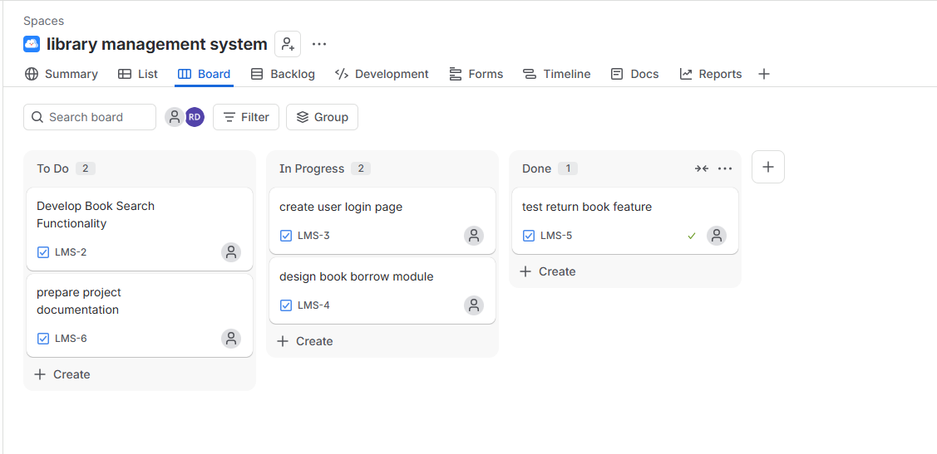
- Jira Issues Embedded & Progress bar added

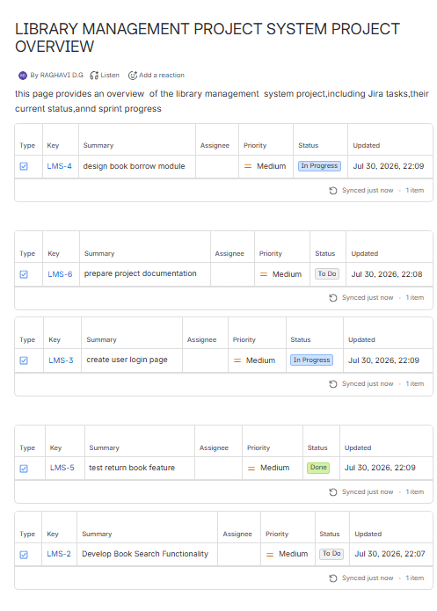

- Final Confluence Page

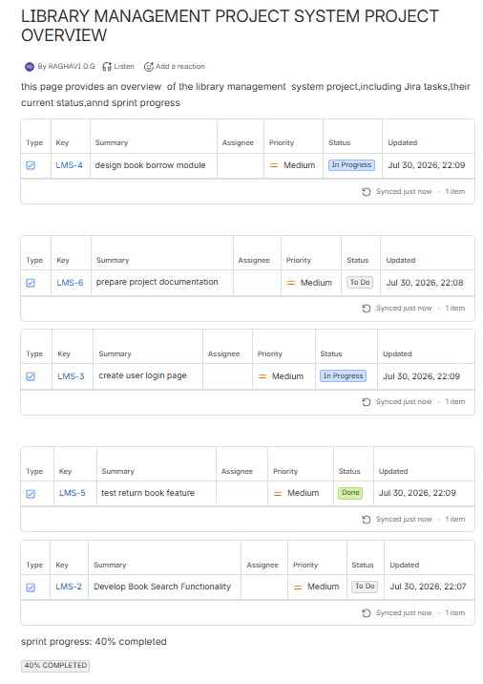

RESULT
The Jira tasks were successfully linked with Confluence by embedding project issues and displaying their workflow status. A progress bar was added to monitor sprint completion, providing a centralized and effective project tracking dashboard for the Library Management System.
EXP : 04 - Prioritize Requirements Using MoSCoW and Kano Models in Jira

AIM
To create and prioritize the requirements of a Task Management System using the MoSCoW and Kano prioritization models in Jira.

WORKFLOW

- Create a New Jira Project

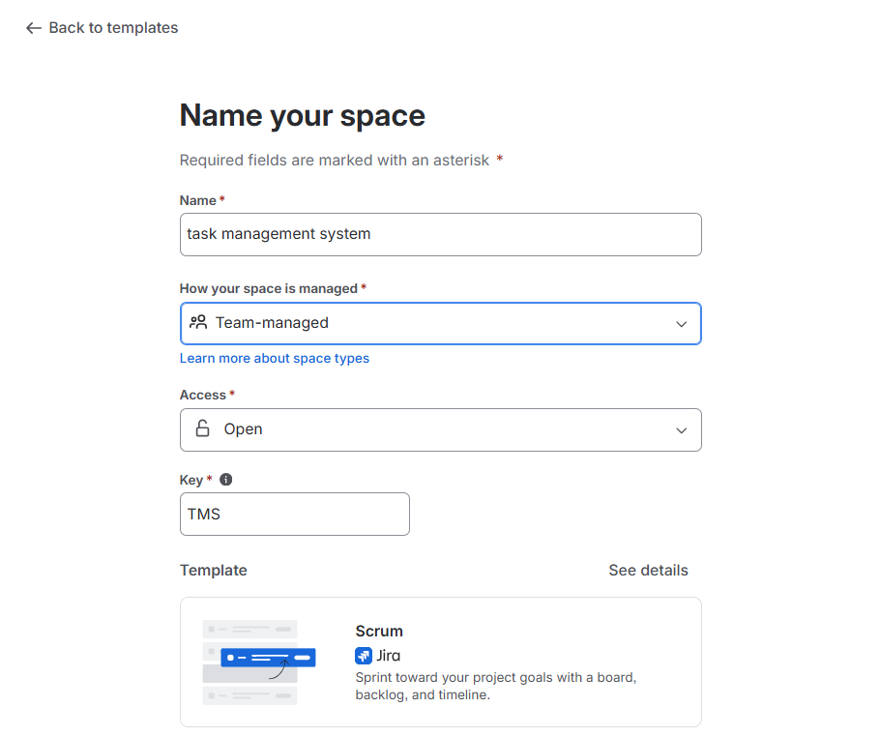

- Create the Project Requirements

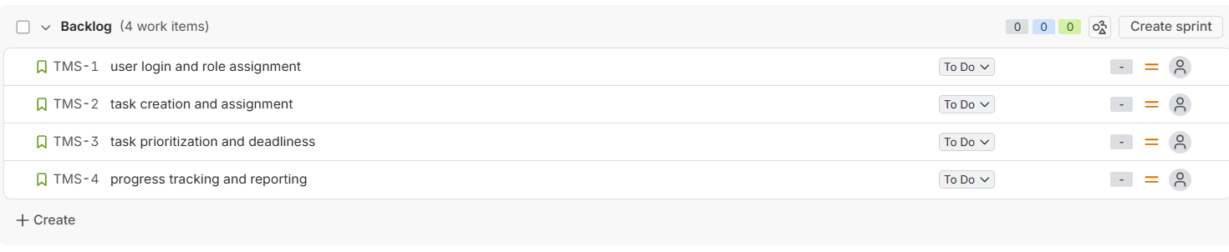

- Prioritize Using the MoSCoW Model

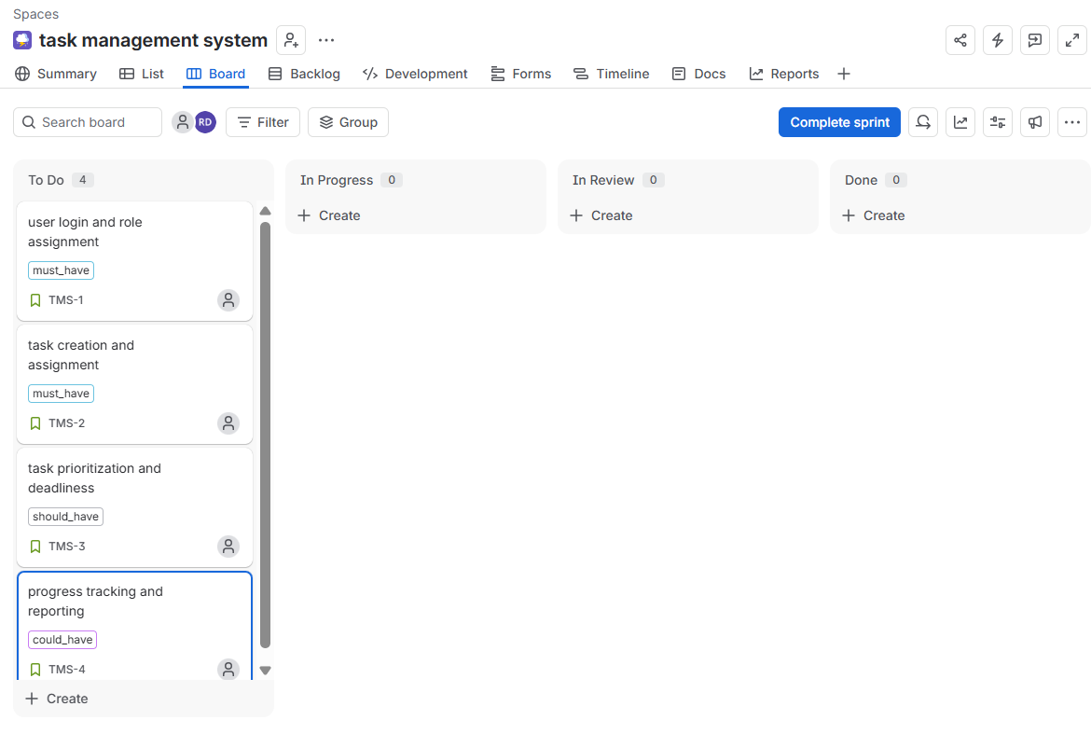
- Categorize Using the Kano Model

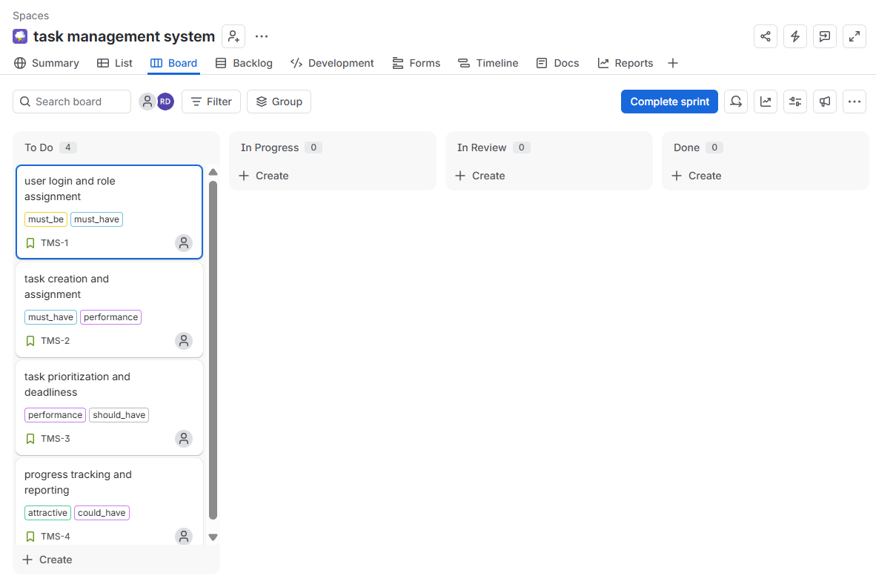

RESULT
The Task Management System requirements were successfully created and prioritized in Jira using the MoSCoW and Kano models. The prioritized backlog helps the development team identify essential, important, and desirable features for efficient project planning and execution.

EXP 05 : Prioritize Requirements Using MoSCoW and Kano Models in Jira (Online Learning Platform)

AIM
To create and prioritize the requirements of an Online Learning Platform using the MoSCoW and Kano prioritization techniques in Jira.

WORKFLOW
- Create a New Jira Project

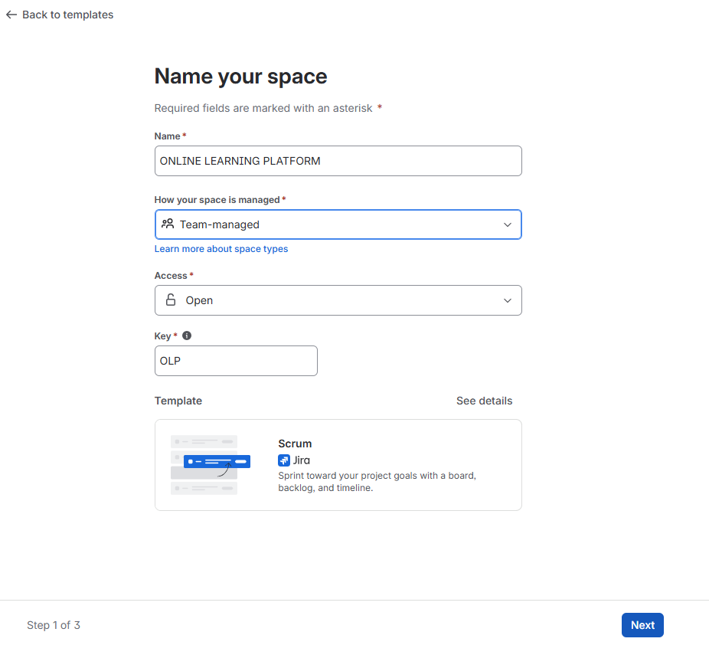

- Create Six Requirements
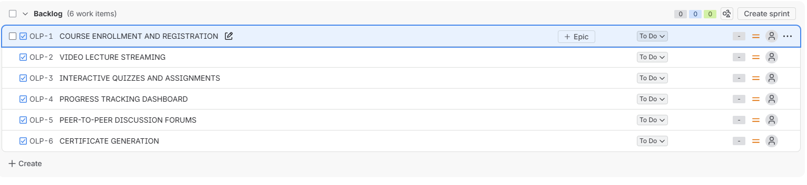
- Prioritize Using the MoSCoW Model

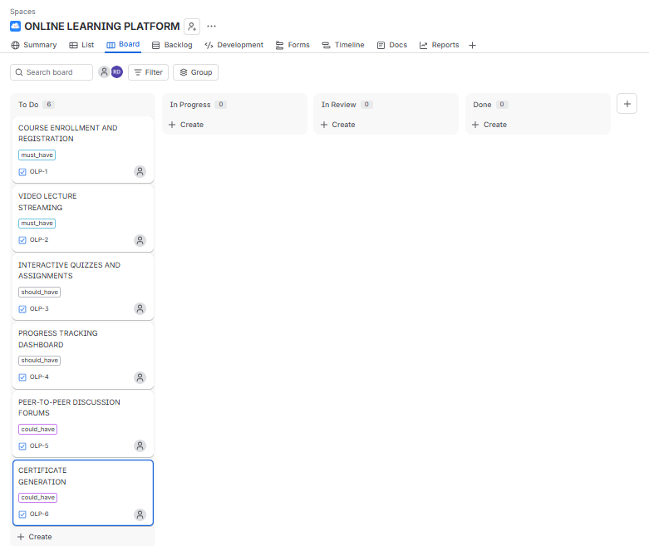
- Categorize Using the Kano Model
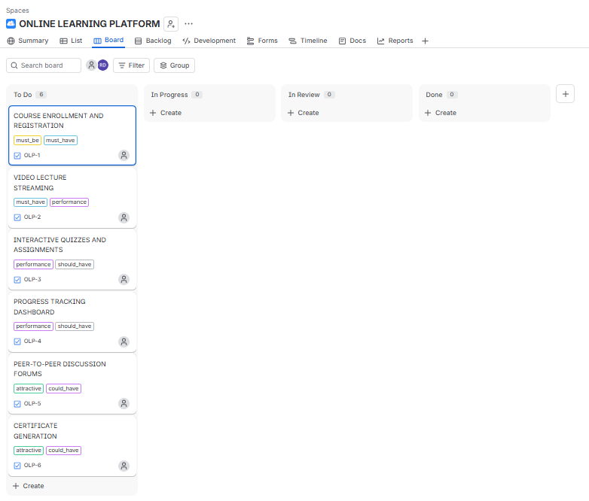
RESULT
Thus, the RAPTOR flowchart for obtaining the lexicographically smallest string by performing at most one swap of two characters was successfully designed, executed, and validated with the expected output.

